INFO6150 Week1 Assignments

Yikai Zhu

1. Send me an email with 4 different websites:

* 1 you think is usable
* 1 you think is not usable
* 1 you think is accessible
* 1 you think is not accessible

1. Website that is usable: Google

I have long been attracted by the simple and beautiful interface of GOOGLE, it consists only an inputbox for you to type what you want to search and two buttons. However, almost everyone in the earth feels it is easy to use google, that’s why it has become one of world’s biggest companies.

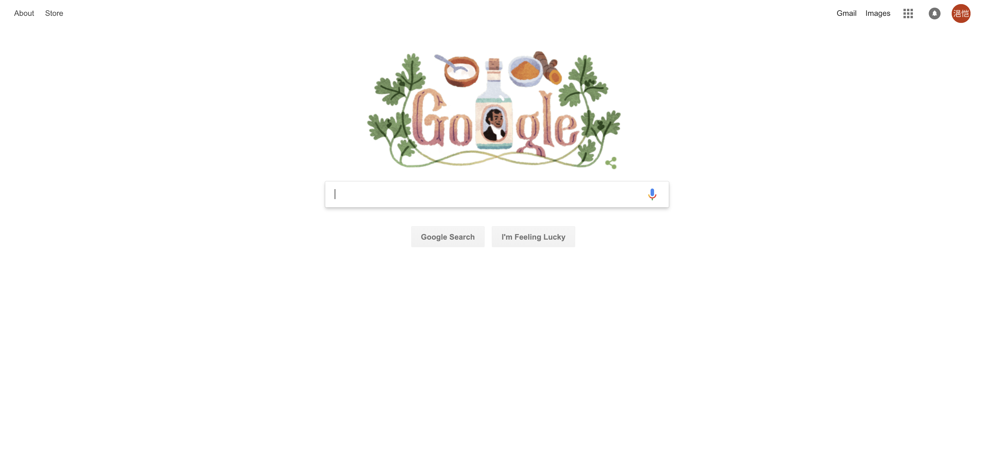

1. Website what is not usable: LinkedIn

I have used LinkedIn for a long time, still I can not get all its functions. When I first signed in my LinkedIn, what I thought is nothing but “what is this? How can I use this website to find some jobs or interns?”. I have spent a long time learning how to use it.

1. Website that is accessible: Zillow

When I was finding where to live before coming to Seattle, I have used many websites, among them, I found Zillow the best one. Because it’s function can be used almost the first time you see it. So there is neither visual challenges nor color challenges.

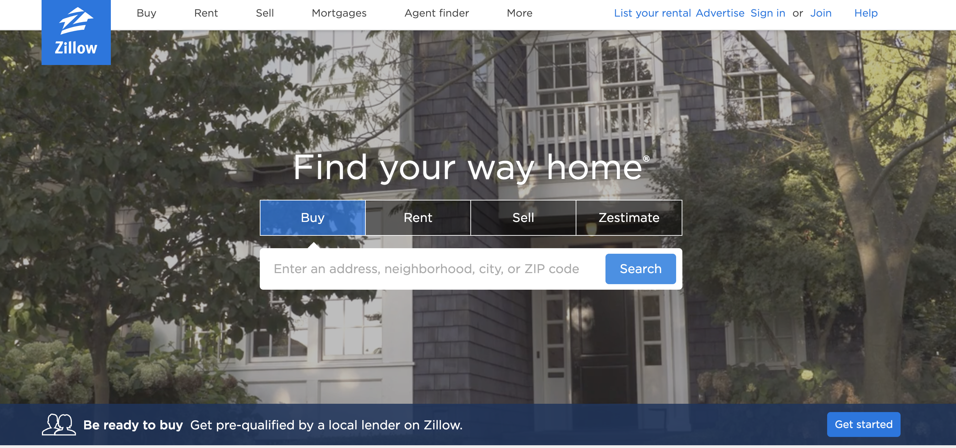

1. Website that is not accessible: <http://design-technology.org/>

To be honest, I never used this site before. I just hanged around the internet and looked into every pages. I found this website is not accessible because its colors are so strange that we can not figure out what the content is and what can I do with this website

